***ASSINGMENT-18.1-***

***Input file data set-***

Hadoop is good subject

Hadoop is good subject

Hadoop is good subject

Hadoop is good subject for me

**QUE18.1.1- Run a map only job on the word count program using static configurations.**

**ANS-18.1.1-**

***Driver-***

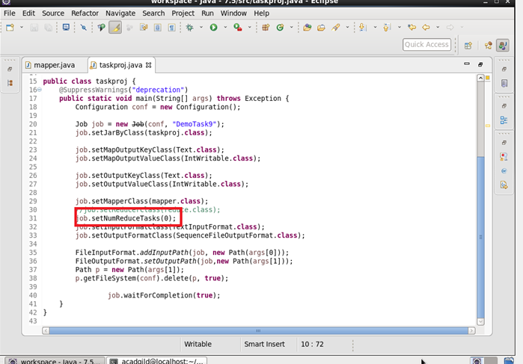

***Mapper-***

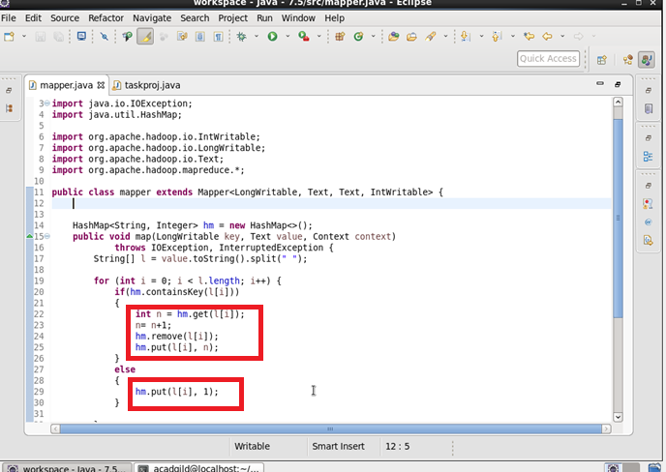

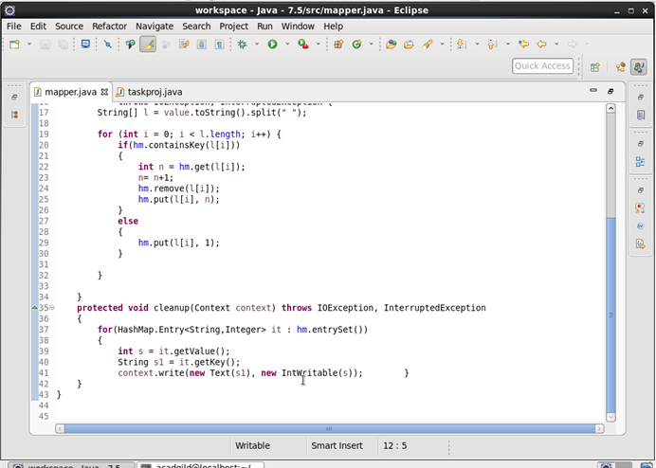

***Output-***

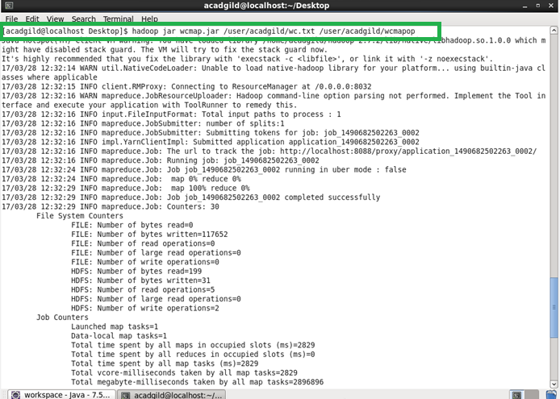

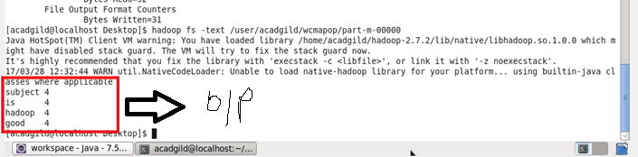

**QUE-18.1.2- Run the mapreduce word count program and set the number of reducers to 2 using static configurations.**

**ANS-18.1.2-**

***Driver-***

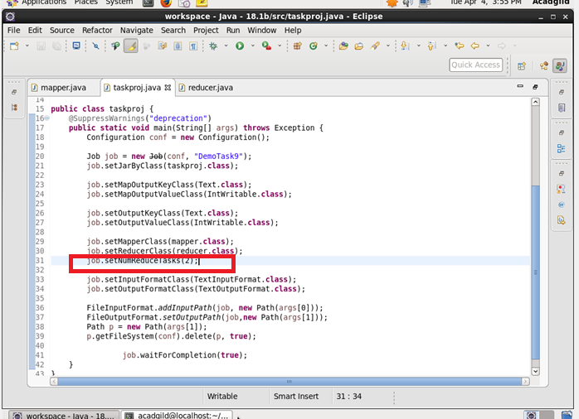

***Mapper-***

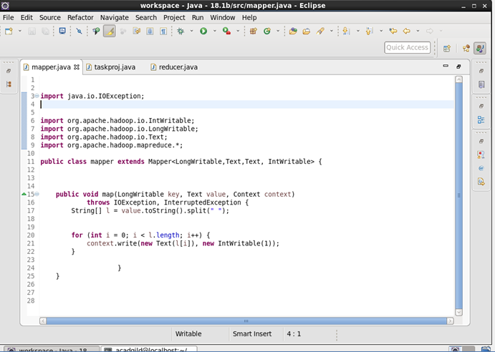

***Reducer-***

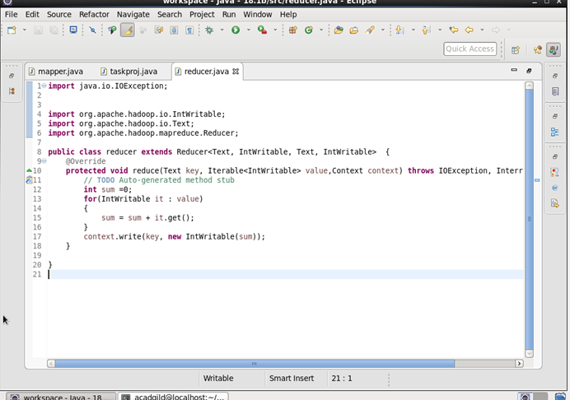

***Output-***

